Exp-3 DML Commands – INSERT, SELECT
Out put:
1.
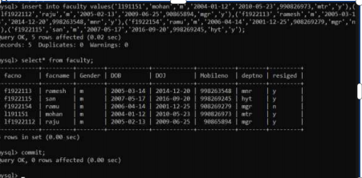
2.
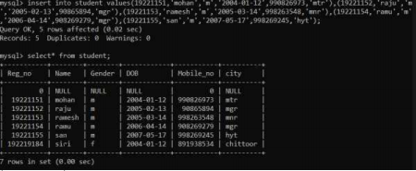
3.
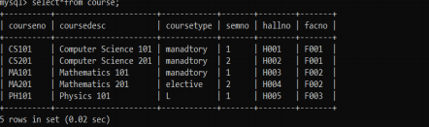
4.
